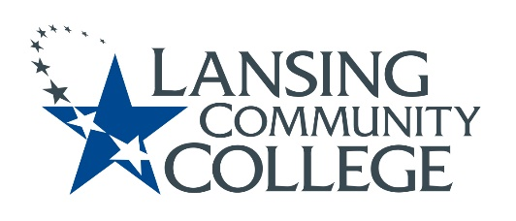
Engagement Committee Agenda with meeting minutes and action items
Nov 22, 2022 1pm

Agenda | Status | F/U Action Items
- Introductions | Completed | Charter members introduced
- Proposed meeting dates, timeframe (are Tuesdays at 1 pm good for everyone?) | Completed | Next meeting Tuesday 1pm, Dec 13,  2022. Will continue with Tuesday meetings a 1pm for the immediate future
- Revisit charter  - Confirm final version  - ?Remove extra language in the Terms section?? | Approved | With edits ready to send to Penny Tucker for website
- Solicit for EC member from CEWD (temp member Nancy Dietrich) | In progress | Working with division and Bo for volunteers…f/u Dec or Jan meeting
- Plan for Spring Senate Elections Faculty Engagement  - Per Eliza (senate discussions during PD days, email senators and supervisors in the areas up for election, advertise in The Star) | In progress | Eliza presented what has been done previously. Will formalize plan of action and priorities next meeting
- Budget committee requests more faculty representation  - Tech Careers (recent loss of member)  - HHS (never had representation) | Not started | Noted, will formalize plan next meeting
- AS President recommendations:  - Reach out to Provost & Deans soliciting for areas wanting faculty representation and possible candidates | Completed | Jon presented some suggestions to reach out to departments to get “recommended” people. Lisa Dobson reiterated EC purpose to encourage diversity and inclusion in recruitment efforts. Karen recommended PD days, department meetings, etc as ways to reach potential members. Jeff suggested we look at finding ways to further engage current AS or committee members.
- Link to draft database for committee consideration Engagement Committee Database DRAFT | In progress | Update as needs and volunteers/recommended folks are identified
- WebEx Team Site Use?? | Approved | Most EC members use WebEx, instructions to download app will be sent by Eliza to those who do not routinely use WebEx. For now, all important communications will be sent in both modalities
10. Reporting cycle to AS | Not started
11. PD Days Jan 2023 | In progress | PD Day session form submitted to CTE for EC. Session details will be formalized at the Dec 13 meeting.

Attendees: all present
- Nathaniel Colon-ODI
- Nancy Dietrich-CEWD
- Lisa Dobson-Tech Careers
- Sarah Garcia-Linz-Student Affairs
- Susan Jepsen-HHS
- Jeff Janowick-A&S
- Eliza Lee-AS Secretary
- Jon TenBrink-AS President
- Karen Tommasulo-Resource Internal Communications

