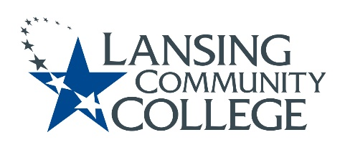

Curriculum Committee Report for the
Academic Senate

Meeting date: 4/05/2023
The Curriculum Committee meets on the 1st and 3rd Wednesday of each academic calendar month.
The following items were discussed and reviewed at the Curriculum Committee Meeting of 04/05/2023.
For those interested in examining the CC documents, they can be found in the folder for Academic Senate review.

Proposed New Program(s) of Study:
- Education, General Associate

Proposed New Courses:
- n/a

Proposed Course Revisions:
- n/a

Proposed Expedited Course Revisions:
- n/a

Proposed Program of Study Discontinuations:
- n/a

Proposed Course Discontinuations:
- n/a

Other business:
- General Education – MTA Humanities Courses Approved:
  - PHIL 215 – Philosophy of Religion
- CIMT Course Revision Approvals:

  - AVGM 111
  - AVGM 112
  - AVGM 113
  - AVGM 114
  - LEGL 125
  - LEGL 207/227
  - LEGL 211
  - LEGL 212
  - MATH 098
  - MATH 109

  - Canceled Course:
    - LEGL 110
    - CJUS 247
    - CJUS 287

Next Curriculum Committee will meet on Wednesday, April 19, 2023, from 2:30-4:30 pm on WebEx.

Respectfully submitted,
Tamara McDiarmid, Curriculum Committee Chair

