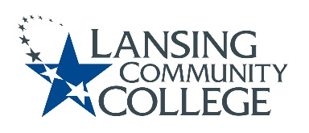

AGENDA: Committee for Assessing Student Learning
Friday, May 5, 2023, 12:30 – 2pm, via Webex
- Approval of the 05/05/23 Agenda
- Approval of the 4/21/23 Minutes
- Chat GPT – standing discussion topic
- D2L Assessment Data Update - Kara
- Status updates on projects from the 4/7/23 Action Items list
  - Academic Senate, Executive Committee, approval status of Chair Elect nomination
    - Possible vote to install nominated Heidi Jordan to that position
  - Finalized CASL Charter
  - Assessment website/Cocurricular webpages
    - Chuck running idea by Library team regarding housing assessment resources under “Faculty Support’ on the LCC Library Page
    - Cocurricular Tab has been added to existing CASL website
- Future agenda items
- Adjourn
  - Next CASL meeting in next academic year
    - If we are following same meeting format would make it Friday September 8, 2023 from 12:30 – 2pm, via Webex

Lansing Community College is an equal opportunity, educational institution/employer.

