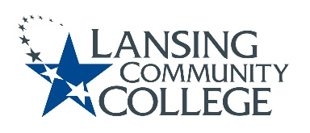

AGENDA: Committee for Assessing Student Learning
Friday, April 21, 2023, 12:30 – 2pm, via Webex
- Approval of the 4/21/23 Agenda
- Approval of the 4/7/23 Minutes
- Status updates on projects from the 4/7/23 Action Items list
  - Confirm members for summer ChatGPT discussion group
  - Academic Senate, Executive Committee, approval status of Chair Elect nomination
    - Possible vote to install nominated Heidi Jordan to that position
  - Finalized CASL Charter
  - Assessment website
  - Cocurricular webpages
- ChatGPT – standing discussion topic
- Future agenda items
- Adjourn
  - Last CASL meeting for this academic year, Friday May 5, 2023 from 12:30 – 2pm, via Webex

Lansing Community College is an equal opportunity, educational institution/employer.

