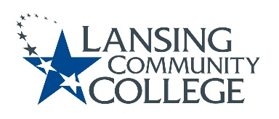

AGENDA: Committee for Assessing Student Learning
Friday, April 7, 2023, 12:30 – 2pm, via Webex
- Approval of the 4/7/23 Agenda
- Approval of the 2/24/23 Minutes
- ChatGPT – standing discussion topic
- Status updates on projects from the 2/24/23 Action Items list
  - HLC Cocurricular Handbook – Karen and Mark Kelland
  - CASL Assessment Website – Tim, Danielle, and Kara
- CASL Charter – Tim and Mark Kelland
- Nominations for Chair Elect
- Assessment verses grades
- Honors Option discussion
- Hyflex modality discussion
- Future agenda items
- Adjourn
  - Next meeting Friday April 21, 2023 from 12:30 – 2pm, via Webex

Lansing Community College is an equal opportunity, educational institution/employer.

