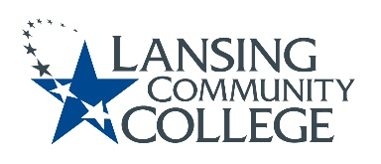

AGENDA: Committee for Assessing Student Learning
Friday, February 24, 2023, 12:30 – 2pm, via Webex
- Approval of the 2/24/23 Agenda
- Approval of the 2/10/23 Minutes
- Gradebook Alignment Resolution, presented to Senate by Tim
  - Update group on Senate response
- Determine who will work on language regarding Chair-Elect in CASL bylaws
- Finalizing Subcommittee Membership
  - HLC tasks: Cocurricular Assessment Handbook & Cocurricular Student Catalog
  - CASL Assessment webpage
- Subcommittee Work
  - Cocurricular Assessment Handbook
    - CASL member review, feedback of handbook
  - Cocurricular Student Catalog
    - Set objectives and timelines
  - CASL Assessment webpage
    - Set objectives and timelines
    - Review of other college assessment webpages
- Future agenda items
  - ChatGPT
  - Assessment verses grades, CASL and Curriculum Committee discussions
  - Honors Option discussion
- Adjourn
  - Next meeting Friday March 24, 2023 from 12:30 – 2pm, via Webex
    - Normal two week meeting, March 3, 2023 falls just before LCC Spring Break so was not scheduled
    - There are 4 more CASL meetings for this academic year

Lansing Community College is an equal opportunity, educational institution/employer.

