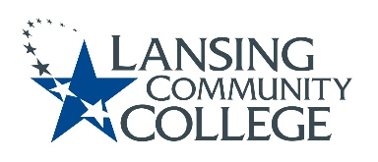

Committee for Assessing Student Learning (CASL) - Minutes
Meeting Held Friday, March 25, 2022, from 12:30 – 1:30pm – via Webex

Team Members:

Present:
Karen Hicks, Heidi Jordan, Mark Kelland, Rob McLoone, Tracy Nothnagel, Laura Orta, and Danielle Savory.

Absent:
Patti Ayers, Timothy Deines, Melinda Hernandez, Mark Khol, Zack Macomber, Rafeeq McGiveron, Chuck Page and Kara Wiedman.

Guest:
Cheryl Garayta

QUORUM NOT MET – MEETING NOT HELD

Next meeting Friday, April 8, 2022 from 12:30pm to 2:00pm, via Webex.

Respectfully submitted by Terri Christian

Lansing Community College is committed to providing equal employment opportunities and equal education for all persons regardless of race, color, sex, age, religion, national origin, creed, ancestry, height, weight, sexual orientation, gender identity, gender expression, disability, familial status, marital status, military status, veteran's status, or other status as protected by law, or genetic information that is unrelated to the person's ability to perform the duties of a particular job or position or that is unrelated to the person's ability to participate in educational programs, courses services or activities offered by the college.

