AGENDA & NOTES
Name of Committee or Team: Committee for Assessing Student Learning (CASL)
Team Members Present: Peggy Dutcher, Karen Hicks, Kara Christensen, Dana Cogswell, Michelle Curtin, Dale Franks, Ed Bryant, Zachary Macomber, Suzanne Bernsten, Reid Felsing, Joe Long
Team Members Absent: Rafeeq McGiveron, Luanne Bibbee, Barbara Clauer, Lisa Nienkark
Guests: Tracy Labadie
Date: September 15, 2017 | Time: 12:00 pm – 1:30 pm | Room: ADM 200

Agenda Item |  | Next Steps
Approval of the notes on 9/1/17 | Add a comma between Dana and Reid in the Team Members Present section.  All approved.
CASL Collaboration with CC – Outcome Review Process | Introduction/ Purpose (Peggy) – We will need CASL members to assist Karen in reviewing outcomes so the Curriculum Committee can continue their work.  Training/Materials (Kara) – Kara will walk CASL through the Introduction to Course Design PowerPoint to see if we can adapt anything and share with the college.  - As shown in the Course Design Funnel, outcomes will start broad and then get specific. We will add the 3 levels of learning outcomes and show how the Enabling Objectives support these. Enabling Objectives may be called Module or Unit Objectives by faculty.  - Begin with the end in mind! Work backwards. What do you want students to accomplish by the end of the course? Group things into similar items and develop your outcomes from there. Change the word core to anchors.  - What are Student Learning Outcomes (SLOs)? Main outcomes that students should achieve in order to show learning in the course. There should be 5-10 SLOs per course depending on what the course is about. These are very broad.  - What are Enabling Objectives? Smaller objectives that students will need to complete in order to achieve the SLOs. Enabling Objectives must align with one or more SLOs. The SLOs and Enabling Objectives should be uniformed for every course. Faculty may call these Weekly Objectives.  - Example 1: SLOs and Enabling Objectives – Outcomes should start with an action word.  - Why use Enabling Objectives? They help faculty during the design process to come up with strategies that match level of outcomes. We want to make sure we are selecting correct assessments. Are you asking your students to do too low or too high level of work? Write the SLOs and Enabling Objectives so students can understand them.  - Developing SLOs and Enabling Objectives: This is where we decide what level we want students to be at.  - Blooms Taxonomy: Bottom 3 sections are Lower Order Thinking Skills (LOTS) and top 3 are Higher Order Thinking Skills (HOTS). There are several versions of Blooms Taxonomy outlines/tables. The bolded words on the Cognitive Domain Verbs are on multiple levels.  - Using Blooms Taxonomy: Determine the level you want students at and select an appropriate action verb for that outcome. What does the course level need to be when we have a blended LOTS and HOTS? Where does the course fit in the sequence? Is it a pre-requisite? Provide smaller type of assessments first to prepare for larger steps. Break assessment into pieces.  - SLOs & Enabling Objectives should not be written as an activity or assessment. If you use more than one verb, you assess at the highest level. | Give Kara feedback on this. Did you think it was useful?  Look over Sample Student Learning Outcome Statements (20). Mark each as good or bad. Are they measureable or observable? Bring this with you to the next meeting.
General Education Assessment Plan | Project Plan Overview (Karen) – Go to the General Education Assessment Plan in today’s meeting folder on SharePoint. We have many tasks we need to complete over the next academic year. The first tab is a list and the second tab is a timeline visual. Anything in grey is going to pertain to the General Assessment Plan. The items in blue to do with our communication plan. Every 2 weeks we will have something due. We need a group to review and edit the year 1 general education section (11-13) and lead the discussion next week. Please go out to the project plan and sign up for more than 1 task.  Topic for Discussion: General Education Areas (Rafeeq & Dana) –The assessment category is confusing. When a specific course is going through the assessment cycle, they might not think the Core or MTA is for them. This is simply for the General Education Assessment Plan. It is how we are going to put groups into the cycle. The first chart does not line up perfectly. The boxes are easy to follow. Dana has the courses that fall into the buckets on the back end. There are 5 unique courses that we will have to decide which bucket they fall into.  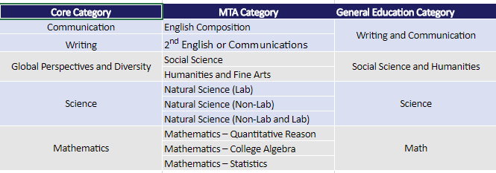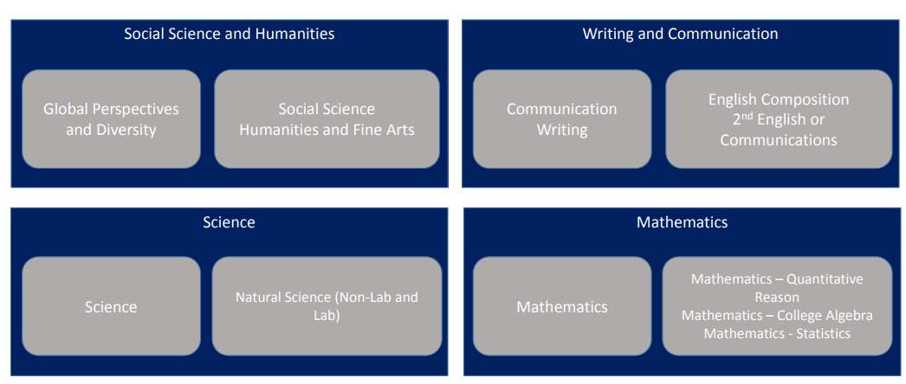
Adjourn | Tracy Labadie is the new Assistant Dean of Academic Affairs. She will be working with Center for Data Science on transitioning the administrative side of Program Review to Academic Affairs. She is cleaning up the articulation agreements and helping launch a transferability study of all of our programs. She is also working on the Systems Portfolio and the Perkins Grant. | Friday, September 29, 2017, TLC 326

