AGENDA & NOTES
Name of Committee or Team: Committee for Assessing Student Learning (CASL)
Team Members Present: Joe long, Peggy Dutcher, Lisa Nienkark, Luanne Bibbee, Suzanne Bernsten, Karen Hicks, Ed Bryant, Zach Macomber
Team Members Absent: Dana Cogswell, Leslie Johnson, Ryan Skiera, Gretchen Arthur, Barbara Clauer, Reid Felsing, Rafeeq McGiveron, Cesar Potes
Guests: Karen Tommasulo, Kara Christensen
Date: November 10, 2016 | Time: 2:30pm – 4:00pm | Room: TLC 326

Agenda Item |  | Next Steps
Approval of the notes on 10/27/16 | All approved.
What’s happening at LCC – Best Practice(s) – Joe Long & his students | SURG 122 Celebrity Game Night- Two groups; Individual from group is provided a term (word) and they must describe this term using clues without using the word. They may pass one time, if they pass a second time, they lose a point. A point is provided every time there is a correct answer. Each group is given 2 minutes to get the most correct answers. We usually run this 3-4 times. This helps students retain information and they enjoy the competition. Joe also printed out an example of what CASL Hollywood Game Night would look like with all CASL terms.  Good sites for interactive teaching/learning:  www.socrative.com  www.getkahoot.com
Assessment Nugget – Peggy & Karen | Program – Program Area – Program of Study – Program Review – Co-Curricular  Peggy pulled the definitions from our Assessment Plan.  - Program Area: Structure of where programs of study are housed.  - Program of Study: A course of study that leads to a certificate or degree.  - Program: A combination of both the programs of study and the structure where programs of study are housed.  - Also used when referring to co-curricular area that does not award programs of study.  - Program Review: The method used to evaluate and improve the effectiveness of programs.  - Academic  - Co-Curricular (New)  The current Program Review deals with academic components. Karen is piloting co-curricular areas.  Karen went over the CASL assessment terminology chart below.  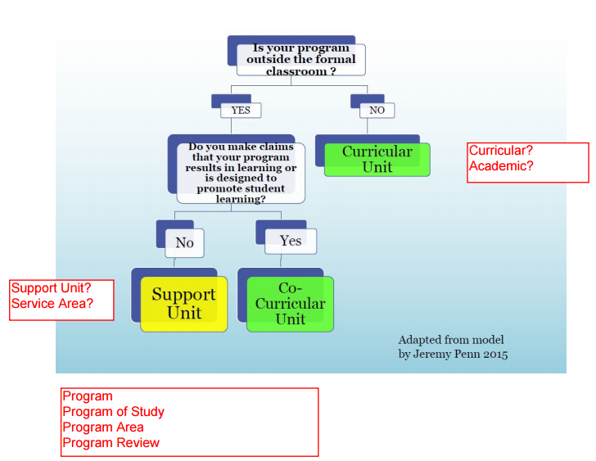  HLC uses the terms academic and co-curricular.  CDS, HR, Finance – Support unit  Service Area – Student Services, Academic Coaches  How would we define the extension centers? CEWD connects to ELO #3. If you align to at least 1 ELO you would be co-curricular. The library would be defined as co-curricular. Support units within the library are technology, tutoring, and space.  Does “your work” align to one of the essential learning outcomes? What does it mean to be put in 1 box versus the other? Our job is to give criteria and tools for the departments to choose for themselves. We will come up with the parameters.
Sabbatical & Conference Sharing – Suzanne Bernsten | Moved to 12/8 meeting.
Update – CASL Charter for Senate Approval | Peggy gave the updated CASL charter to Jeff Janowick last week. They will use it as a template for new committees.  Small adjustments:  - They want CASL to collaborate with all of the standing committees, not just the Curriculum Committee.  - We had 70-75% faculty listed in membership. We changed it to 70%.  - We listed every division including the President’s office. We removed President’s office.  - We listed the number of members per divisions. We removed this.  This will go for approval at the last Academic Senate meeting.
Introduction to a Communication Plan – Karen T. & Peggy | The communication plan template is in the 09-15-2016 SharePoint folder. CASL will pilot this template. The communication plan is a resource to help us think strategically. The template is set up by project. We will have multiple projects.  - What is the missing information that people need to receive? How does this advance the mission of LCC? Make sure this is valuable to the audience.  - Define the audience. Who do I need to talk to? Narrow it down to you get to the smallest group. You can have multiple audiences.  - What is the message the audience needs to hear?  - What tools are you going to use? This is where we can get creative.  - Assign people.  Small group work: Objectives vs Outcomes vs Topics vs Goals project. Answer all questions on the template for faculty and administrators. Link project to outcomes. Use online template.
Adjourn | Please spread the word about the CASL webpage. Ask to have a short segment on CASL during your department meetings. | Next Meeting:  Thursday, December 8, 2:30-4:00,  TLC 326

