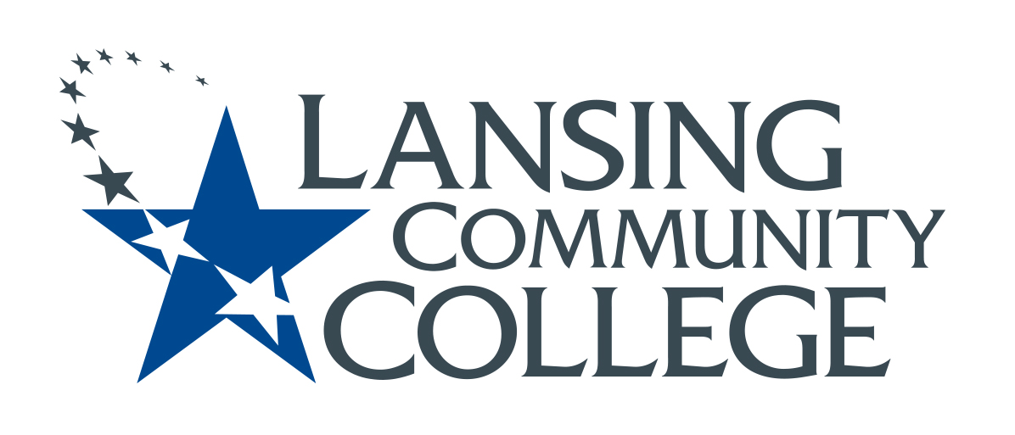

minutes

Budget Committee
Friday, February 11, 2022
8:10-9:05 AM

Present: Alexandra Beard, Nancy Dietrich, Gerard Haddad, Andrea Hoagland, Eva Menefee, Sally Pierce, Jon Ten Brink, Jean Ramirez, Kabeer Ahammad Sahib, Mark Stevens, Denise Warner

Agenda
- Jan. 28 meeting minutes were approved
- The group discussed and revised the draft of the Innovations Grant Application. There were many questions about what a PIE team is. Denise agreed to contact Mindy Wilson for clarification. A brief description of PIE teams will be added to the application. Denise will invite Mindy to our next meeting for Q&A.
- As we discussed the draft, we also discussed the process for review of applications by the Budget Committee. There will be several small groups of 3 to review incoming applications so that the entire committee can share this work. The small groups will bring the applications to the full committee so that all committee members will see every application and have a voice in approving the application.
- Future Agenda Items/Next Steps
  - Get reports from all of the division budget meetings taking place this month

Meeting minutes respectfully submitted by Denise Warner.

Next Meeting: Feb. 25

