Email Clean-Up Strategy:
Sort by Size and Eliminate Largest Emails

A couple things to keep in mind:
- Email is not an approved storage location for records. Email messages, or information contained within them, that are considered to be College records must be identified and stored in a separate system such as a shared workspace folder on the N:\ drive. You can find more information about email as records on the FAQs about RIM webpage.

- In Outlook, when you scroll to the bottom of the list of emails in a folder you will most likely see a message that says “There are more items in this folder on the server. Click here to view more on Microsoft Exchange.”
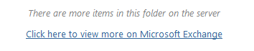
Be sure you click the link to bring up all the items before you sort.

- Consider deleting emails that are larger than 1 MB.

How to Sort by Size and Eliminate Largest Emails (in Outlook)

Reading Pane view: OFF
To Sort:
- Look for the “SIZE” column header near the right side of the screen.
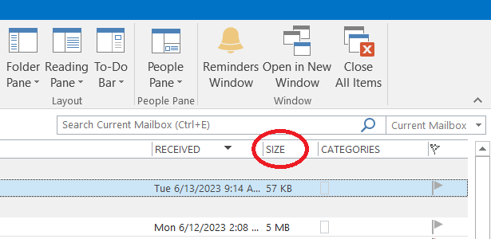
- Click on the column header. This will change the view so that the folder is now being sorted by size instead of date (RECEIVED), which is the default.

To Delete:
- Click on the top (largest) item.
- Hold the Control key and click on other items to select multiple items.
- (Or hold the Shift key and click on another item to select all the items between the two.)
- Then click the Delete button in the Home ribbon or hit the delete key on your keyboard.

To go back to the default sorting, click on the “RECEIVED” column header.

Reading Pane view: ON
To Sort:
- Look for the “By …” item above the list of emails. (The default is “By Date”)
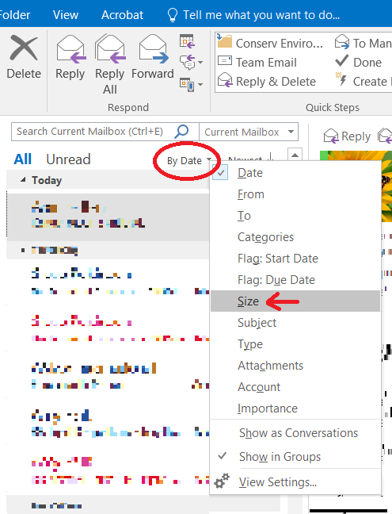
- Click on the arrow just to the right of this item and a pop-up list will appear with options for how to sort the list of emails in the folder.
- Click on “Size” to re-order the list by size.

To Delete:
- Click on the top (largest) item in the list of emails.
- Hold the Control key and click on other items to select multiple items.
- (Or hold the Shift key and click on another item to select all the items between the two.)
- Then click the Delete button in the Home ribbon or hit the delete key on your keyboard.

To go back to the default sorting, click on the arrow again and choose “Date” or whichever option your folder is normally sorted by.

