Email Clean-Up Strategy:
Sort by Date and Eliminate Oldest Emails

A couple things to keep in mind:
- Email is not an approved storage location for records. Email messages, or information contained within them, that are considered to be College records must be identified and stored in a separate system such as a shared workspace folder on the N:\ drive. You can find more information about email as records on the FAQs about RIM webpage.

- In Outlook, when you scroll to the bottom of the list of emails in a folder you will most likely see a message that says “There are more items in this folder on the server. Click here to view more on Microsoft Exchange.”
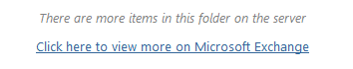
Be sure you click the link to bring up all the items before you sort.

- Consider deleting emails that are older than three years.

How to Sort by Date and Eliminate Oldest Emails (in Outlook)

Reading Pane view: OFF
To Sort:
- Look for the “RECEIVED” column header near the right side of the screen.
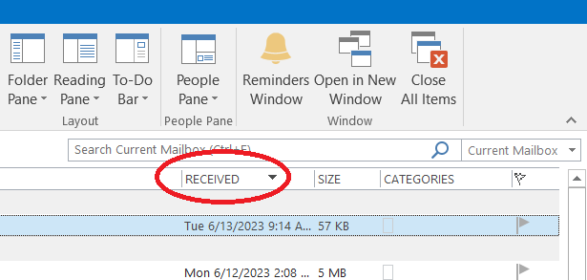
- Click on the arrow to the right of the column header to reverse the date order from oldest to newest.

To Delete:
- Click on the top (oldest) item.
- Hold the Control key and click on other items to select multiple items.
- (Or hold the Shift key and click on another item to select all the items between the two.)
- Then click the Delete button in the Home ribbon or hit the delete key on your keyboard.

To go back to the default sorting, click on the arrow to the right of the “RECEIVED” column header to reverse the date order from newest to oldest.

With Reading Pane view: ON
To Sort:
- Look for the “By …” item above the list of emails.
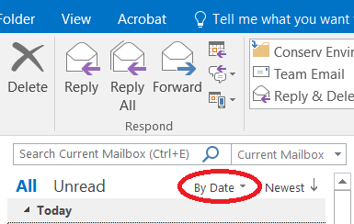
  - The default is “By Date.” If it’s not already sorted “By Date” click on the arrow just to the right of this item and a pop-up list will appear with options for how to sort the list of emails in the folder.
  - Click on Date to re-order the list by date.
- Click on “Newest” just to the right of “By Date.” This will re-order the list from oldest to newest and the item will change to say “Oldest.”

To Delete:
- Click on the top (oldest) item in the list of emails.
- Hold the Control key and click on other items to select multiple items.
- (Or hold the Shift key and click on another item to select all the items between the two.)
- Then click the Delete button in the Home ribbon or hit the delete key on your keyboard.

To go back to the default sorting, click on “Oldest.” The list will go back to being sorted from newest to oldest and the item will change to say “Newest” again.

