Email Clean-Up Strategy:
Delete Items in Sent & Deleted Folders

A couple things to keep in mind:
- Email is not an approved storage location for records. Email messages, or information contained within them, that are considered to be College records must be identified and stored in a separate system such as a shared workspace folder on the N:\ drive. You can find more information about email as records on the FAQs about RIM webpage.

- In Outlook, when you scroll to the bottom of the list of emails in a folder you will most likely see a message that says “There are more items in this folder on the server. Click here to view more on Microsoft Exchange.”
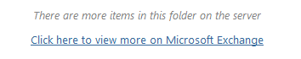
Be sure you click the link to bring up all the items before you sort.

How to Delete Items in “Sent” Folder (in Outlook)
- Right click on the “Sent Items” folder in the list of folders.
- Choose “Delete All.”

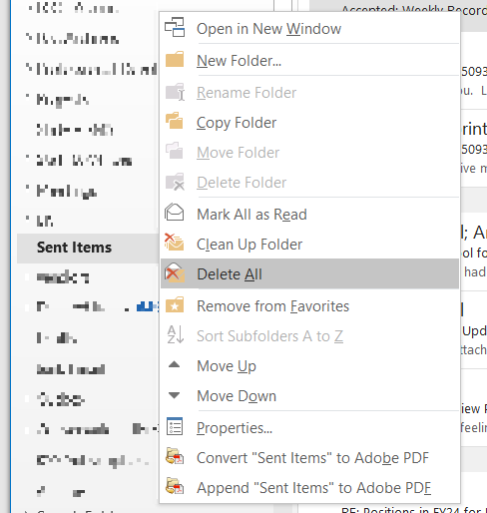

How to Delete Items in “Deleted” Folder (in Outlook)
- Right click on the “Deleted Items” folder in the list of folders.
- Choose “Empty Folder.”

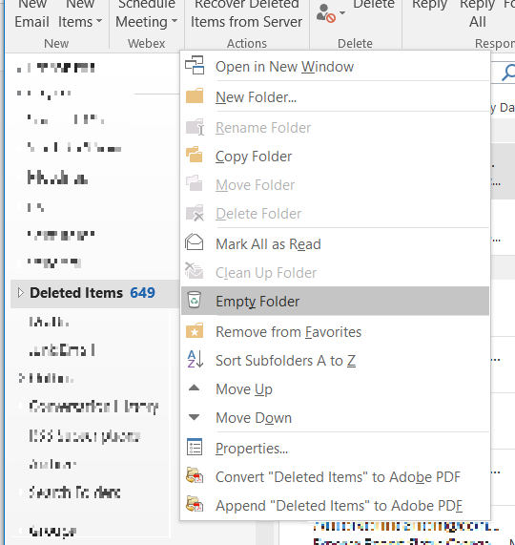

- A pop-up box will say “Everything in the “Deleted Items” folder will be permanently deleted. Continue?”
- Click “Yes.”

