Talent Management System Job Aid
Contents
Access the TMS 2
Allowing Pop-Up Windows 4
View Assigned Trainings 5
How to Request/Register for Training 6
Curriculum/Tests 8
Running Reports 10
Assign Training 11
Performance Reviews 13
Uploading Documents to Snapshot 16
Live Event/WebEx Training 19
If you have any technical issues or questions, please contact the
LCC Help Desk at x5221.

Accessing the Talent Management System (TMS)
Access “myLCC” and then click the “Work” tab. Click on the “Talent Management System” link in the Employee eToolbox.
Training courses work best with Google Chrome, Firefox, Safari and Microsoft Edge. It is important to make sure the browser is updated to the latest version and not blocking pop-up windows
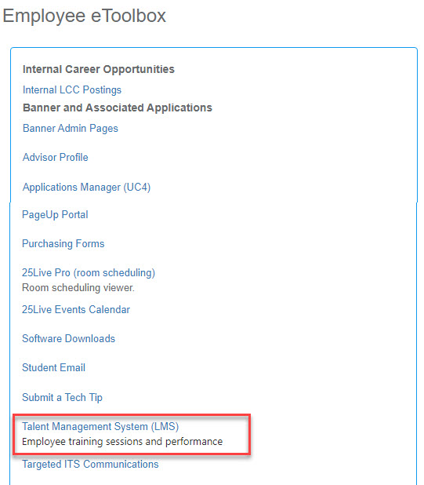

This will access the homepage of the Talent Management System. From here you can see your tasks for any performance reviews. Below that is an image which is a link to your training transcript. This will contain all assigned online training courses. It shows those that you need to complete, along with those that you have completed. There is also a section called “My Inbox” which will list any important notifications, such as training approvals.
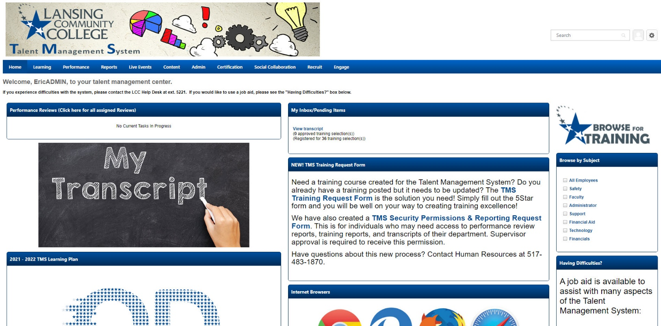

Allowing Pop-Up Windows
The TMS launches training courses in a separate browsing window. It is important that the web browser is not blocking pop-up windows. When you launch a course and the screen displays the message below for a long period of time, this is an indicator that the browser is stopping a course from launching. Each browser should display an error message and provide steps to allow pop-ups from the TMS.
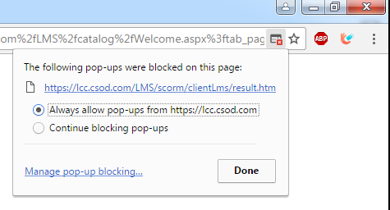

View Required/Assigned Trainings
Access the “Talent Management System” homepage. Clicking the “My Transcript” image will take you to your training transcript. You can change the “Active” listing to “Completed” to see a list of all the courses you have completed. Click the “Launch” button to begin an online training for which you’re registered.
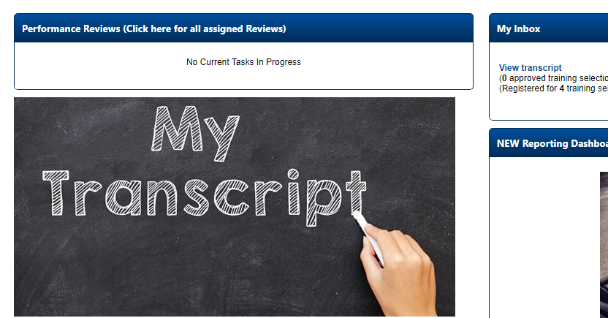
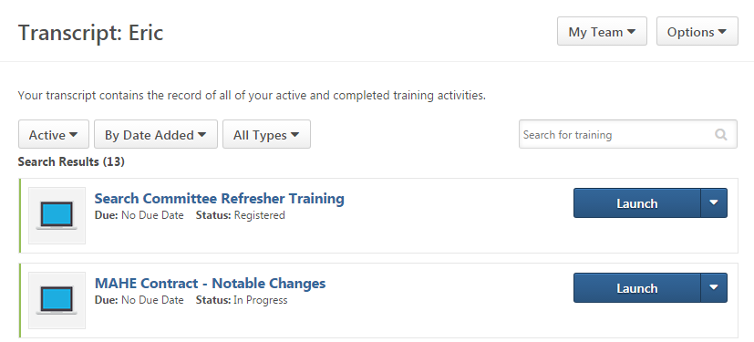

How to Request/Register for Training
Access the “Talent Management System” homepage and click the “Browse for Training” picture in the upper right corner of the page to search for available trainings.
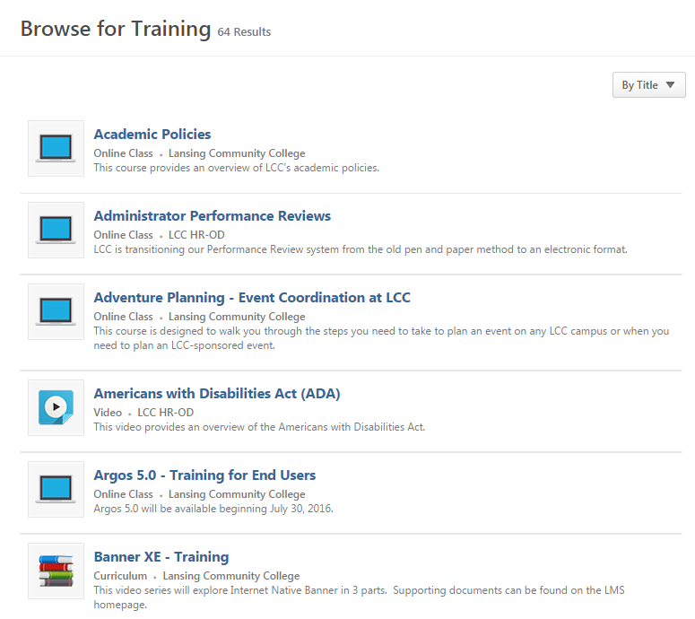

Click the desired online course or training session to view details. If you would like to take a course listed here, click the “Request” button. If the course is immediately available, you will then be able to launch the course. If the course requires an approval, the organizer will be notified of your request and will approve or deny the request. You will receive an email indicating if you have been approved for the course. If approved, you may access the online course or event details from your transcript.
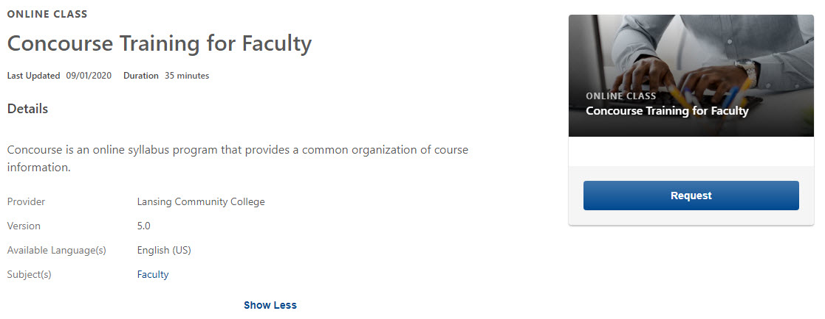

Curriculum
Some trainings may have multiple courses or may require that a test be completed in addition to completing the course(s). These are listed as “Curriculum.” Click “Open Curriculum” and then “Launch” to activate and launch courses and tests.
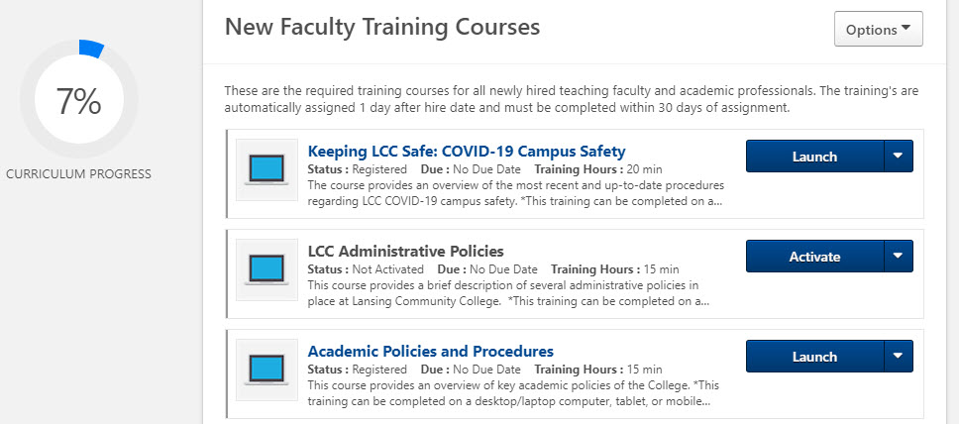
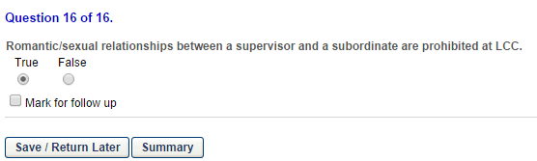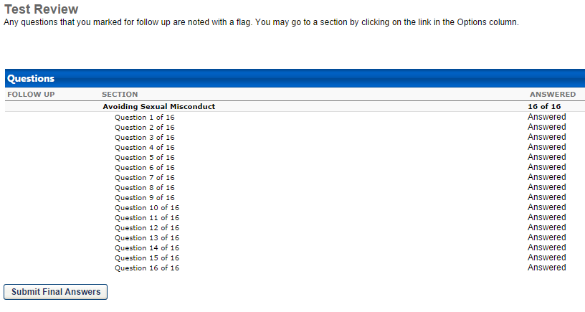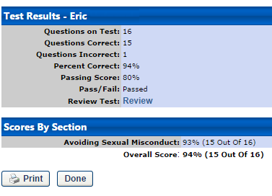
When you have completed a test, the “Summary” will appear.
Click “Submit Final Answers” to submit the test.
Review the test results then click “Done.” You may retake a test as many times as necessary until you achieve the passing grade. There is also a link to review your answers and receive feedback.

Running Reports in the TMS (Admins & Select Support Staff Only)
After logging into “myLCC,” access the “Talent Management System” homepage. From the welcome page, you will see “Reports” at the top in the blue bar. Hover or “Reports” and then click “Reporting 2.0” below. Click “Shared with Me and you will then see the reports you have access to. All reports can be downloaded in Excel format by clicking the icon.
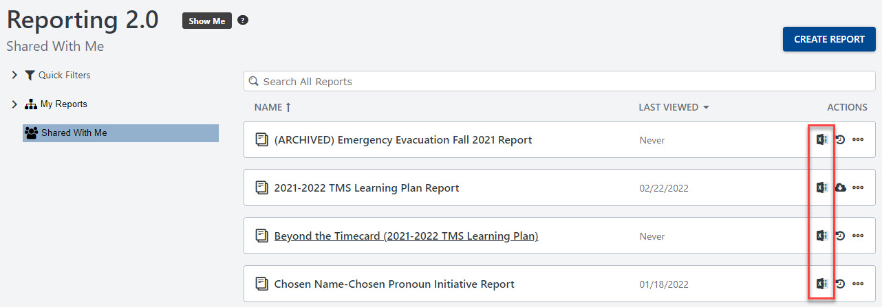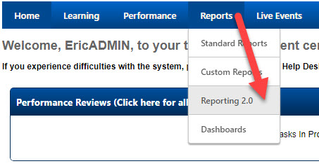
Under the “Actions” column, click the Excel icon and the report will process and automatically download.

**NOTE: You must have permissions set to utilize the reports area of the TMS. For more information, please contact your supervisor and submit a “TMS Security Permissions & Reporting Request Form” found on the TMS homepage.**

Assign Trainings in the TMS
If you have staff that report to you, there is an option to assign training courses to those employees. After logging into “myLCC,” access the “Talent Management System” homepage. From the welcome page, click the “Browse for Training” image to search for available trainings.
Click the desired online course or training session to view details. Click “Assign” to see a list of direct reports you can assign the training to. Select the desired employee(s) and then click “Submit.” The training will then be assigned.
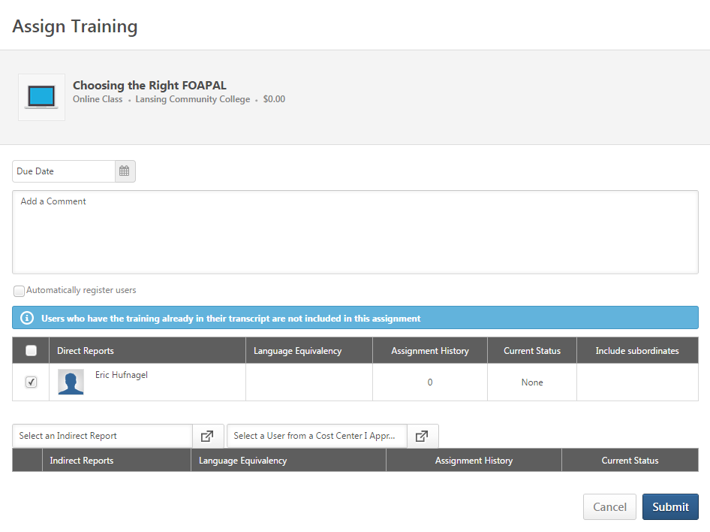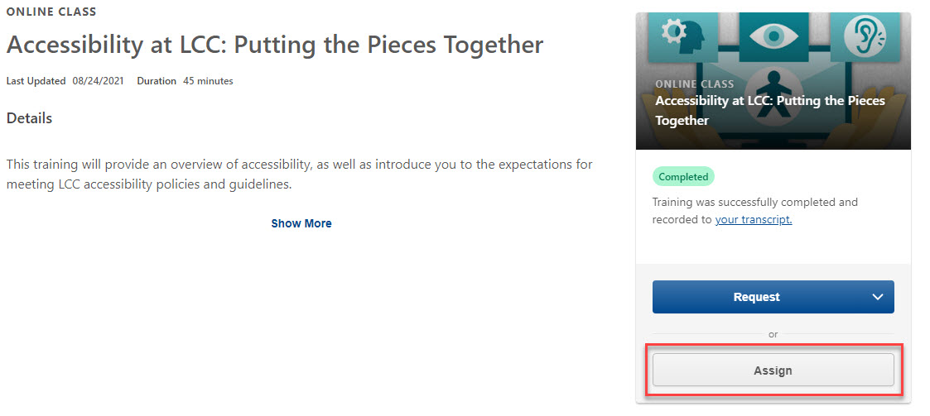

Accessing a Performance Review Task
If you receive an email from HR-OD indicating you have a task to complete in the Talent Management System, log into the TMS via your “myLCC” account. On your TMS homepage, the box titled “Your Tasks” contains the link to the task to be completed. Click a task to go to the overview screen.
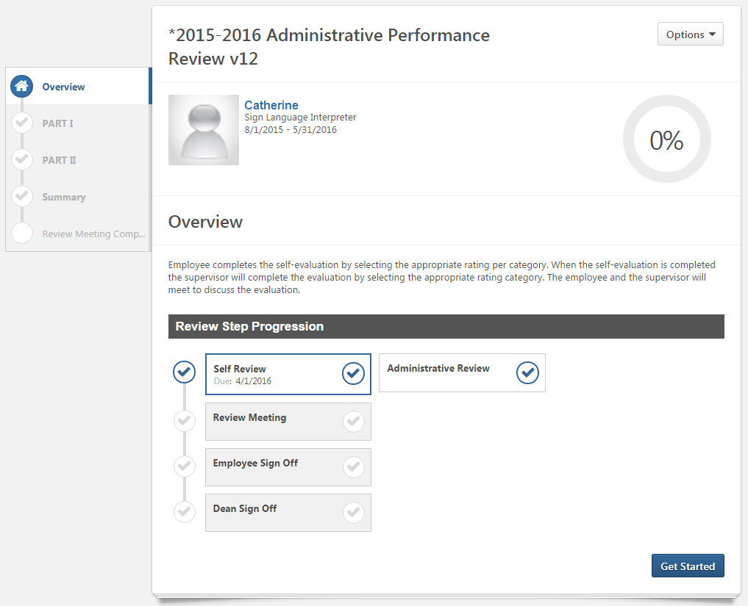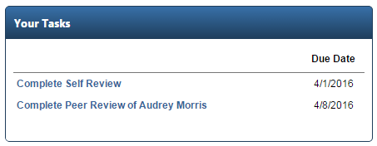

At the bottom of the review page, click “Get Started” to begin an assigned task.
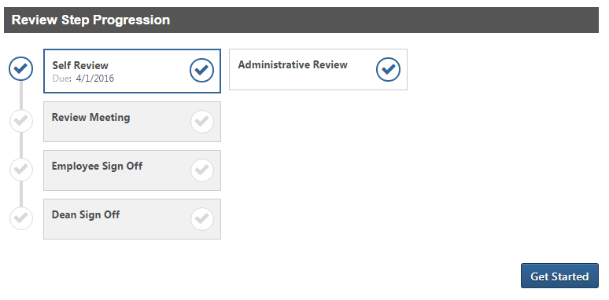
You can save a task at any point and return to it at a later time by using the buttons at the bottom of a review page. When a task is completed, you can return to the review to create a PDF and print a copy if needed (under options by the task title, seen below).
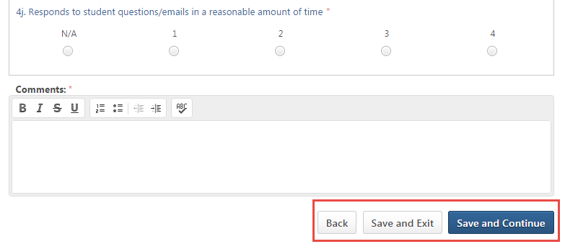
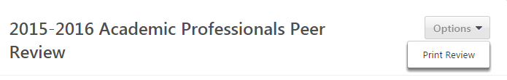

Viewing Completed Reviews
To view completed performance reviews, click the “Universal Profile” link from the TMS homepage.
Click “Snapshot” to access uploaded documents and completed performance reviews. Once a review is opened, there is an option to print the review.
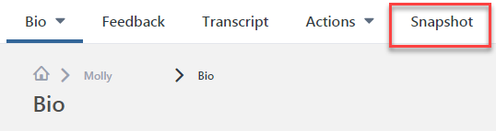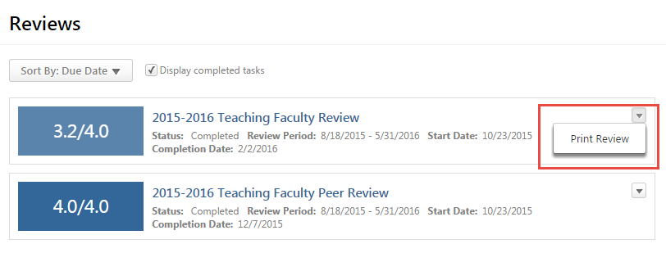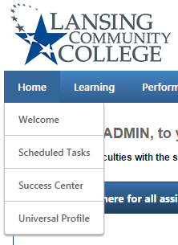

Uploading Documents to Snapshot
Snapshot can be used to upload faculty portfolios, external training, or certifications. To upload documents for a performance review or any other reason, click the “Universal Profile” link from the TMS homepage. Once at your Universal Profile page, there will be a menu to the left. Click the “Snapshot” link to be taken to the Snapshot homepage. Click the “Documents” box.

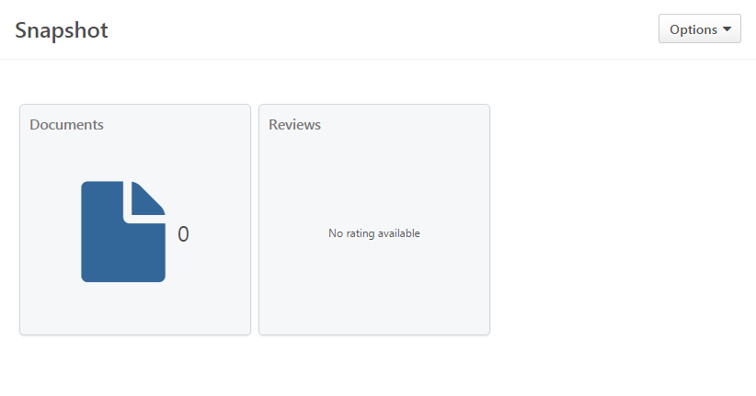
Click the desired folder to be taken to the document list. A button for adding documents will be available. Click “Add File” to open the add file dialogue box.

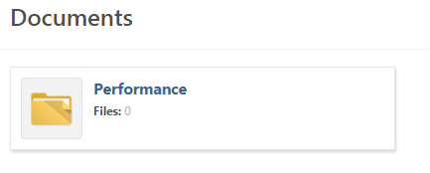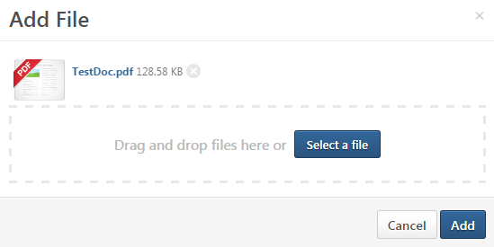

Click “Select a file” to choose a document for upload. Most file formats are supported (PDF, Word, Excel, PowerPoint, etc.). Once the files have been selected, click “Add” to upload them to your Snapshot folder.

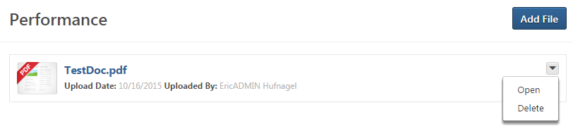
All documents loaded with Snapshot will have to option for viewing or deleting.

Additional Questions:
- Can my supervisor view documents I upload?
  - Yes (See below for instructions)
- Can my supervisor delete anything I upload?
  - No
- Can my supervisor upload documents to my Snapshot?
  - Yes
- Can my peer reviewer or administrative reviewer view documents I upload?
  - Yes (see below for instructions)
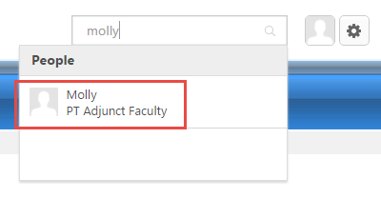
If you are a supervisor or a peer reviewer, type the name of the individual in the search field of the TMS. You can click their name and access their uploaded Snapshot documents.

Registering for Live Event/WebEx Trainings
Access the “Talent Management System” homepage and click the “Browse for Training” picture in the upper right corner of the page to search for available trainings. Select the event you are looking for and the training details and available sessions will display. Click the “View Details” dropdown menu and select “Request.”
**NOTE: You must register for a session to be properly added to the roster.**
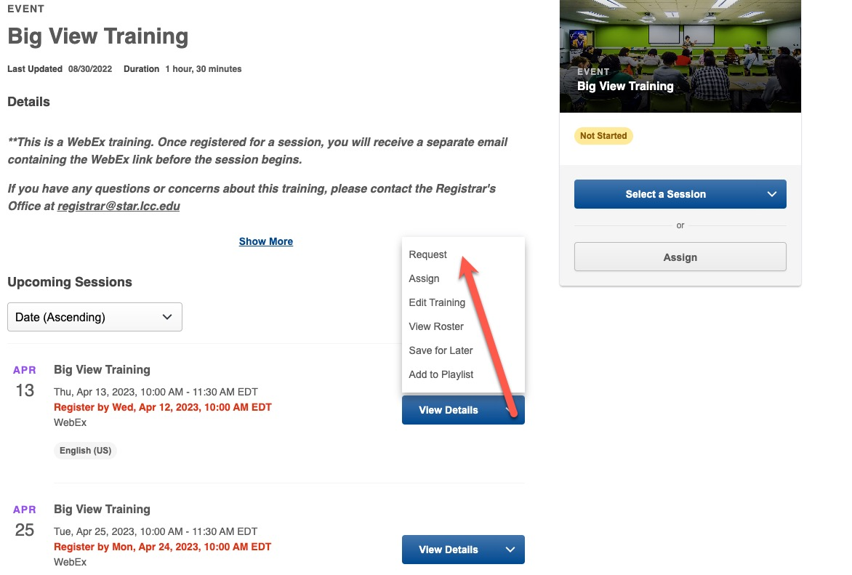
Once registered, you will receive an email confirmation with an Outlook invite (for in-person trainings). For WebEx trainings, in addition to the confirmation email from the TMS, you will receive a separate email with the WebEx link and details an hour before the session begins. The TMS confirmation email will not contain an Outlook invite.

If you require additional assistance, please contact the LCC Help Desk
at ext. 5221

