Pay Check/Stub
A Pay Check/Stub is a document an employer provides to an employee, which outlines all wage and deduction data.
Currently showing is the Earnings section of the Pay Check/Stub.
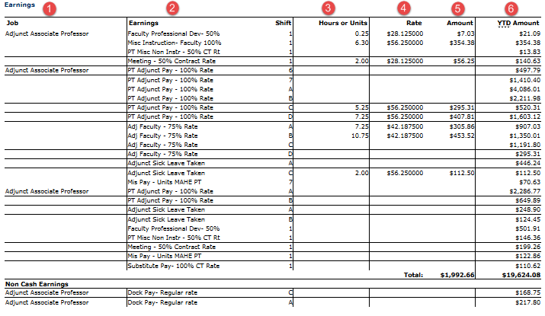 Job
- Employee position(s)

Earnings
- Identifies which type of earnings are being paid during pay period.
  - Example: Adjunct 100% Rate, Committee pay, Meeting pay, Sick time, etc.

Hours or Unit
- Time submitted for payment via Faculty Pay System (timekeeper) or Web Time Entry (timesheet submission).

Rate
- Hourly rate of pay per offer letter or bargaining unit contract.

Amount
- Gross Wages

YTD Amount
- Total amount of wages paid during calendar year.
  - Restarts every January 1st

Types of Earnings
Different types of wages paid to Adjunct employees in return for labor or services.
Earn Code | Description | Earn Code | Description | Earn Code | Description
ADJ | PT Adjunct Pay - 100% Rate | DOC | Dock Pay- Regular rate | POO | Parking Opt Out
AF5 | Adjunct Faculty - 50% Rate | FML | Family and Medical Leave Act | REM | Retroactive MAHE PT
AF7 | Adjunct Faculty - 75% Rate | FPD | Faculty Professional Dev- 50% | RTM | Retro - Current Year MAHE PT
ASL | Adjunct Sick Leave Accrued | GTR | Grant Hours Override | SCM | Sick Leave Prescheduled
AST | Adjunct Sick Leave Taken | JUR | Jury Duty | SCU | Sick Leave Unscheduled
BRM | Bereavement Leave MAHE PT | MHM | Miscellaneous Pay - MAHE | SEV | Severance Pay
CCD | Course Dev - 50% Contract Rate | MIN | Misc Instruction- Faculty 100% | SK5 | PT Adjunct Faculty-Sick Bank
CCO | Course Coord-50% Contract Rate | MNI | PT Misc Non Instr - 50% CT Rt | SPM | Supp Pay - Lump Sum MAHE PT
CLO | Closed Campus | MTG | Meeting - 50% Contract Rate | STM | Stipend MAHE PT
COM | PT Committee-50% Contract Rate | MUM | Mis Pay - Units MAHE PT | SUB | Substitute Pay- 100% CT Rate
DGM | Degree Recognition MAHE PT | OW2 | Overtime - Weighted Avg - Wk 2 | UNR | Union Release Time
DKS | Dock Pay - Special Rate | PEA | Personal Leave Adjunct | UNS | Union Related Work Special Rt

Workload Hour
One workload hour is equal to 16 contact hours of classroom instruction or 32 hours of non-teaching work in a bargaining unit. (1 work load hour = 16 contact hours = 32 clock hours)

Adjunct Base Wage Calculation
To calculate adjunct wages figure the total hours of pay and divide by the number of pay periods that fall within the start and end dates of the course. Lansing Community College uses the following information to calculate each adjunct employees’ wage.

- Each course credit counts as 16 hours of pay.
- 1 credit = 16 hours of pay
- 2 credits = 32 hours of pay
- 3 credits = 48 hours of pay
- 4 credits = 64 hours of pay

- Go to the Payroll Pay Schedule located on the Payroll Website.
  - If course is full semester, the number of pays are shown at the bottom of the Payroll Pay Schedule in the color key.
  - If course is less than the full semester, use the Payroll Pay Schedule’s start and end dates to calculate the number of pays that fall in between beginning date and ending date of the course.

- Calculation of bi-weekly wage:
  - Course credits multiplied by 16 hours of pay = total hours of pay for semester.
  - Total hours of pay for semester divided by the number of pays within the course start/end dates = bi-weekly hours to be paid.
  - Bi-weekly hours to be paid multiplied by hourly rate of pay = bi-weekly gross wages.
Adjunct Base Wage Calculation Examples
Example #1: Full semester course
Course Information

  - Course 12345, BIOL123
  - 4 Credits
  - Spring Semester 2019 – Start date: 1/14/19, End Date: 5/17/19

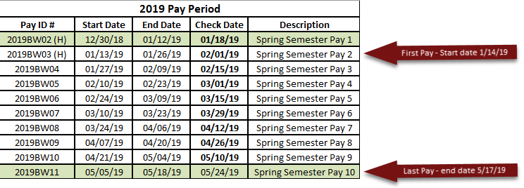
Wage Calculation

- 4 credits x 16 hours of pay = 64 hrs
- 64 hrs divided by 9 pay periods = approx. 7.0 hrs per pay period (each pay will vary in 0.25 (quarter hour) increments to account for the full payment of the 64 hours)
- 7 hrs x $30.00 hourly rate of pay = $210.00 gross wages
- $210.00 bi-weekly gross wage will be paid for 9 pays

Example #2: Partial semester course
Course Information

  - Course 67890, MATH555
  - 3 Credits
  - Spring Semester 2019 – Start date: 1/28/19, End Date: 3/22/19 (8 weeks)

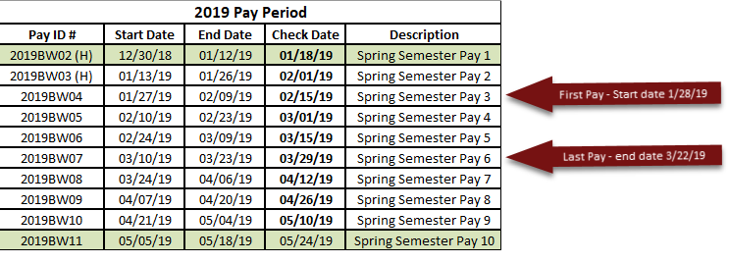
Wage Calculation

- 3 credits x 16 hours of pay = 48 hrs
- 48 hrs divided by 4 pay periods = 12.0 hrs per pay period
- 12 hrs x $30.00 hourly rate of pay = $360.00 gross wages
- $360.00 bi-weekly gross wage will be paid for 4 pays
If you have questions regarding your pay check/stub, please contact the Payroll Department at FS-Payroll@lcc.edu or Ext 1799.

