Response Rate Monitoring
When the evaluation opens for student input, faculty can begin monitoring their response rates at the same time. Viewing real-time response rates of “Live” evaluations is one of the powerful features of Blue.
The course instructor(s) will receive an email notification when students begin filling out their evaluations. Your Subject Management Area in Blue will allow you to see live response information. From this you can determine if you need to take action to increase student participation. As a reminder, to ensure student confidentiality, at least three students must complete an evaluation form to generate a report for you. If you see a low rate there are things you can do to increase student responses. This handout walks you through the process.

Items discussed in this handout:
- Faculty Notification
- Using the Subject Management Area
- Ways to Increase Response Rates
- Where to submit questions/comments

Faculty Notification
Faculty will receive an email notification, that includes a link for their use, when their section evaluation is open for students input (“Live”) and ready for response rate monitoring . Most end of semester course evaluations are available for students to complete 30 days prior to the course end date. Less time may occur for early ending courses and formative evaluations.
The links these emails provide take you directly to your Subject Management area in Blue. The link may route you through LCC’s sign in page to get there, please log in using your LCC sign on credentials.
Here’s an example email:
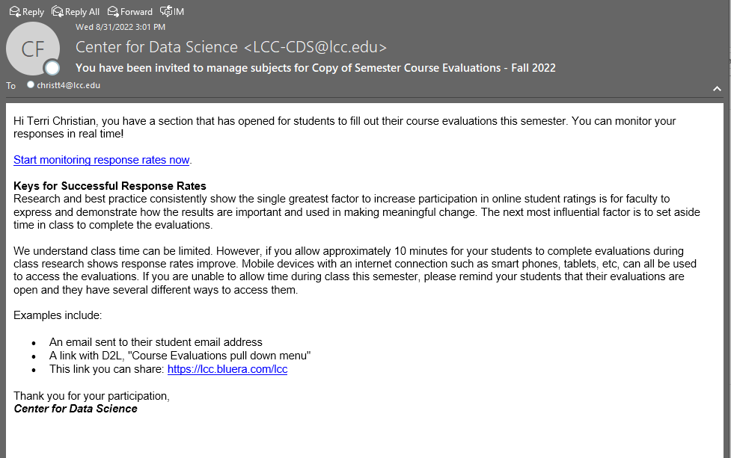
You can also access this area from the task list on your Blue home page or the Subject Management link on the top of that home page.
Here’s a sample Blue Home Page indicating 3 ways to access the Subject Management area:
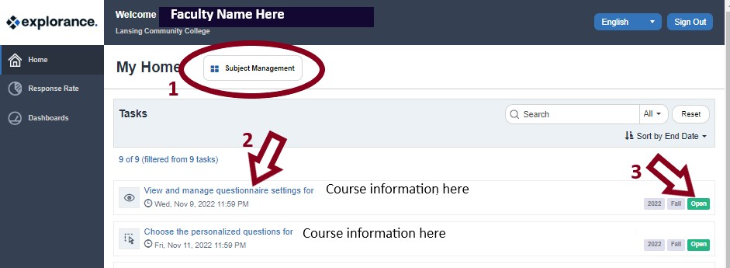
- You can select the Subject Management button on the top of the page.
- You can select a specific task name.
- You can select the open button in a specific task.
Faculty teaching full semester courses will receive two reminder emails, with links, regarding monitoring their response rates. The first reminder will be 10 days after the evaluation started and the second 21 days after evaluation start date. Faculty teaching shorter term courses may only receive one email reminder.
Note: You do not need to wait for email notifications but can go to your Blue home page at any time to review all your course tasks and reports. Options include: Use this Blue Home Page Link: https://lcc.bluera.com/lcc/; bookmark the site once you are there and use that; or use the Explorance Blue link found in myLCC employee toolbox.

Subject Management Area

Viewing response rates means you are looking at “Live” blocks in your Subject Management Area. In the sample “Live” block, next to this paragraph, you can see the circled Live designation. Student information includes number invited, number that have started but not submitted, number of submitted responses, any opted out students (LCC doesn’t use this option), the end date of the evaluation, and the overall response rate percentage. Also on this example, the arrow indicates where to click for more options.
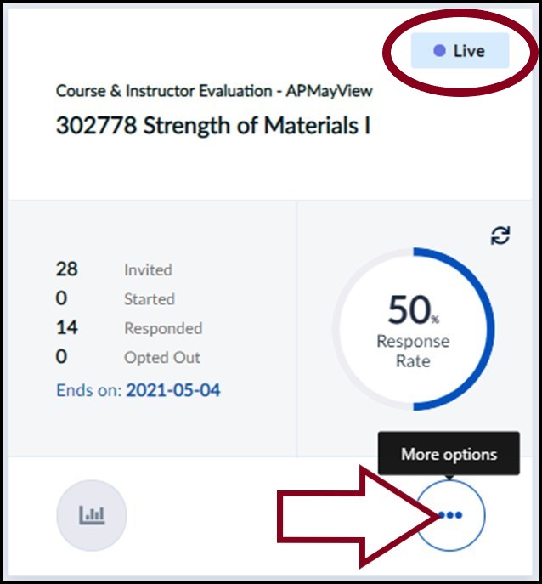

Selecting the three dot “More options” button allows you to choose between viewing settings and viewing respondents. During response monitoring the evaluation is live so LCC recommends you not change any settings at this time. However, if you select review respondents you can see the roster of students that are being sent the evaluation and if they received an email. For end of semester course evaluations you may also see if they have completed the evaluation, but you will not be able to see what their responses were on an individual basis. Students are called “raters” in the Blue system, because they are rating the courses.
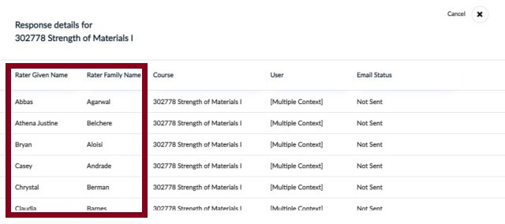
Once done viewing click the “x” in the upper right corner to close the view.

Ways to Increase Response Rates
Students receive initial emails (to their LCC student email address), with links, when the evaluation is open for their input. They will also receive up to three reminders, once they submit the evaluation the reminders will end. Reminder 1 is sent ½ way through the open evaluation window, reminder 2 is sent when the evaluation time is 80% over, and the third reminder is sent the day before the evaluation closes. Students also receive popups for open evaluation tasks when logging into D2L.
The emails and D2L popups are handy default measures to let students know about the course evaluation. However, those are often simply ignored. The best way to increase student response rates is to have faculty involvement. There are three proven ways faculty can increase their response rates: Create value for students; In-class capture; and Monitor and communicate. These give a lot of impact but don’t take a lot of time.

Create Value for Students
Research and best practice consistently show the single greatest factor to increase participation in online student ratings is for faculty to express and demonstrate how the results are important and used in making meaningful change. One faculty, Kristine Cuddy, LCC Community Health Service, who had a 100% response rate puts it well:
“I really stress to the students that it’s as important for me to have their feedback as it is for them to have my feedback during the course. Also, that I take to heart the good, the bad and the ugly, that I learn something new every day and their input is vital for me to learn and grow and be a better instructor.”

In-class Capture
Setting aside time in class to complete the evaluations is the next most influential factor in getting good response rates. Allowing approximately 10 minutes, for any course modality, can make a huge difference in your response rates. Daniel Rafail discusses his face-to-face sections and how he had an 82% response rate in LCC Computer Information Technologies:
“I find the highest response rates in face-to-face sections when we take time during a regular class session for evaluation because it becomes a priority for students that does not compete with other classes, work, family or other outside obligations.”

Monitor & Communicate
By using Blue to check on response rates you can keep your class updated on their progress. Jeff Janowick, from LCC History, used this technique to get an 85% response rate.
“I kept the class updated as to their progress-OK, we’re at 50, 65, 75 percent. I also made sure they knew how many more students had to complete it to get to the 80 percent target. I think this gave some of the holdouts the incentive to complete.”
Note: Students can use computers or mobile devices with an internet connection such as smart phones, tablets, etc. to access their evaluations. You can remind them to look at their LCC student email inboxes for evaluation reminders, click on D2L popups, or post the standard Blue home page link for their use on your D2L page (it will take users to their specific home page) Blue Home Page Link: https://lcc.bluera.com/lcc/.

Where to submit questions/comments

Questions regarding information from this handout
Please direct any questions regarding information from this handout to the Center for Data Science at lcc-cds@star.lcc.edu. Someone will reply to your email as soon as possible.

Offering comments and/or other feedback regarding this handout
This system is ever evolving and your input is valued. Please send any comments or other feedback to the Center for Data Science at lcc-cds@star.lcc.edu. Content/system changes will be forwarded to CASL for their review and discussion. Any proposed content/system changes will be voted on during their meeting and implemented by CDS upon their request.
---
LCC provides equal opportunity for all persons and prohibits discriminatory practices based on race, color, sex, age, religion, national origin, creed, ancestry, height, weight, sexual orientation, gender identity, gender expression, disability, familial status, marital status, military status, veteran's status, or other status as protected by law, or genetic information that is unrelated to the person's ability to perform the duties of a particular job or position or participate in educational programs, courses, services or activities offered by the College.

