Question Personalization (QP) Tasks
There are 14 universal questions that will be required for each course evaluation. These were determined by the faculty led Committee for Assessing Student Learning (CASL) and make up the default evaluation. More details on these questions can be found in a separate handout. In addition to those questions an instructor has the option to customize their evaluation by choosing from a bank of other questions and/or creating their own. This customization is referred to as the question personalization task.

Items discussed in this handout:

- Faculty Notification
- Subject Management Area
- Question Personalization (QP) Area
- Adding Questions to Your Evaluation
- Copying QP from one section to another
- Important Information for Team Taught Courses
- Universal Program Questions
- Previewing Student View of the Evaluation
- Submitting Your Evaluation
- Where to submit questions/comments

Faculty Notification
Faculty will receive an email notification and see D2L popup reminders when their section evaluation is ready for their customization. For end of semester evaluations, the window opens 30 days before the evaluations are available for students to fill out. Most end of semester course evaluations are available for students to complete 30 days prior to the course end date. Less time may occur for early ending courses and formative evaluations.
The links these emails/popups provide take you directly to your Subject Management area in Blue where you customize your course evaluation settings. You can also access this area from the task list on your Blue home page or the Subject Management link on the top of that home page. More details can be found on this process in the “Accessing your Blue home page” handout.
It is not necessary to add additional questions. If you are not planning on customizing your evaluation go directly to the Submitting Your Evaluation section at the end of this handout. Submitting your evaluation will stop D2L and email reminders.

Subject Management Area
Once in your Subject Management area, select an evaluation block where there is an incomplete task remaining and click View Settings.

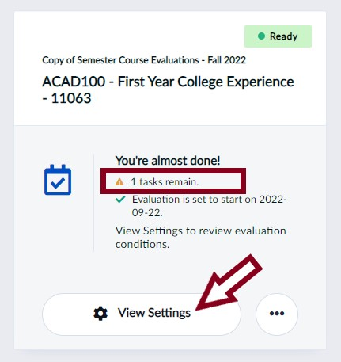
In the “Choose your questions” section click on the arrow pointing right. This will take you to the Question Personalization area.

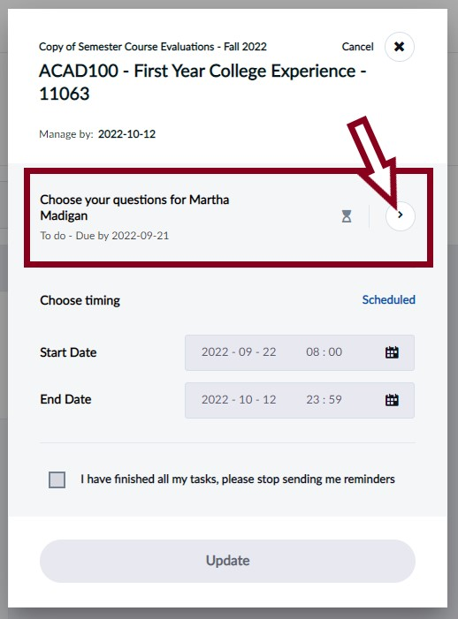

Question Personalization (QP) Area
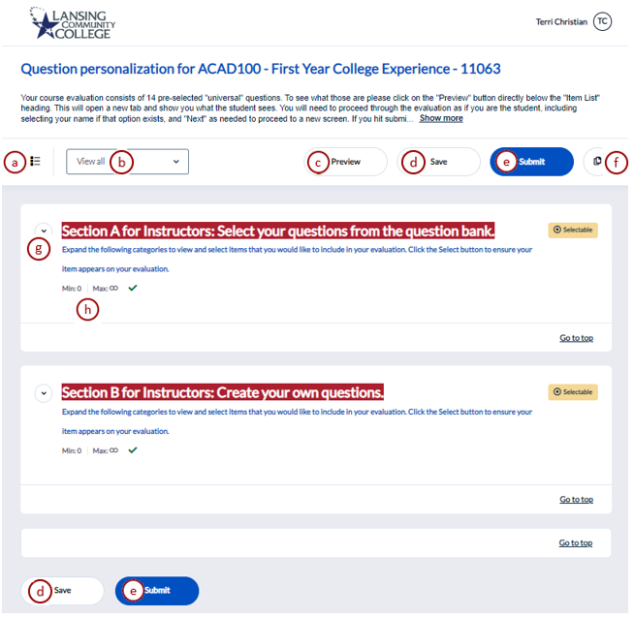
Legend for QP features:
- Table of contents - Provides a simplified overview of question sections you can personalize. You can play around with this feature but it is not described in more detail here.
- Filter - Filters the list of questions displayed.
  - View All - All available questions.
  - Selectable - Only questions that can be selected.
  - Customizable - Only personalized questions that can be modified.
  - Included - Only questions that have been chosen to be included in the questionnaire.
  - Excluded - Only questions that have been chosen to be excluded from the questionnaire.
- Preview - Allows you to preview a sample of your evaluation from the perspective of your students. Make sure to save your changes before using the preview function, see Previewing Student View section later in this handout.
- Save - Saves your changes on the page without submitting.
- Submit - Submits your personalized questions to be included in the evaluation. You can update after submitting until the evaluation is open for students to enter their responses.
- Copy Options - Allows you to copy selections and personalized questions to or from another course. To learn more, see Copying QP from one section to another later in this handout.
- Expand Arrow - Allows you to expand or collapse question previews for the section.
- Number of questions condition - Displays the minimum and maximum number of personalized questions allowed in the specific section. A green check mark means the section conditions have been satisfied. LCC does not use this feature.
Once you expand questions you can see a few more options:
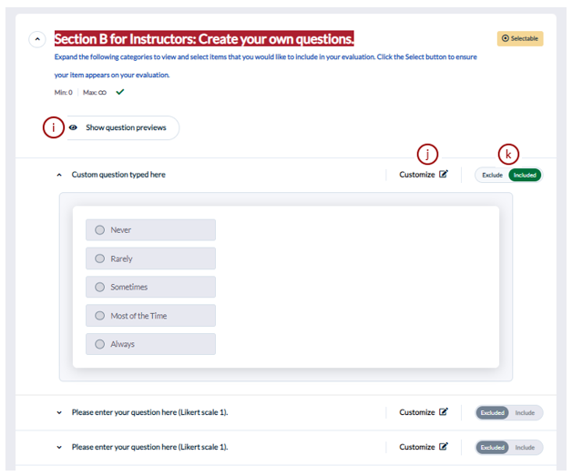
- Show question previews - Allows you to expand or collapse all question previews for a specific section in the questionnaire.
- Customize - Allows you to customize the question.
- Include/ Exclude - Allows you to include or exclude a question from the evaluation.

Adding Questions to Your Evaluation

Selecting from prewritten questions, aka the question bank
To select questions from a premade list, once on your QP page select the down arrow next to the “Section A for Instructors: Select your questions from the question bank” heading. This will expand the selection list. Simply choose the select button beside the questions to have them added to your evaluation. If you would like to see the details of how the question is laid out select the down arrow next to it. Below is an image showing an expanded question from Section A for Instructors.
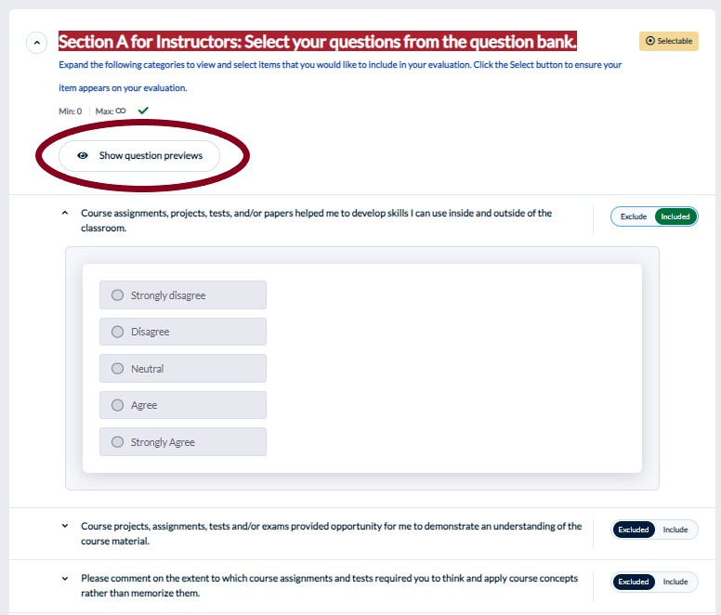
You can select the “Show question previews” button at the top of Section A to see the details of all questions without having to select them individually. When you are done looking at the section you can select the arrow, now pointing up, next to the section heading to get back to your initial QP page look.
Caution! Be sure to save your work as you move through this process! If you exit without saving your changes will not be kept. Don’t worry if you clicked “Submit” instead of “Save.” You can continually update your evaluation until it goes active for student input.

View of update options:
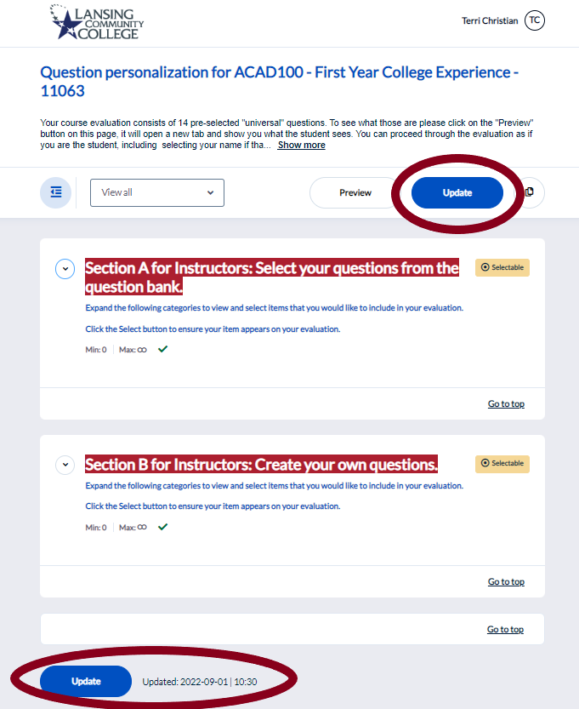

Creating Your Own Questions
To create your own questions, from your QP area select the “Show Section” button in “Section B for Instructors: Create your Own Questions.” Just like in Section A, select the Edit button directly to the left of the question title to see more details on an individual basis or select the “Open All Questions” option to see all details available.

There are three type of questions that can be added.
- Likert Scale 1 which has the student select one of the following choices: Strongly Disagree, Disagree, Neutral, Agree, or Strongly Agree.
- Likert Scale 2 which has the student select one of the following choices: Never, Rarely, Sometimes, Most of the Time, or Always.
- Comment Questions
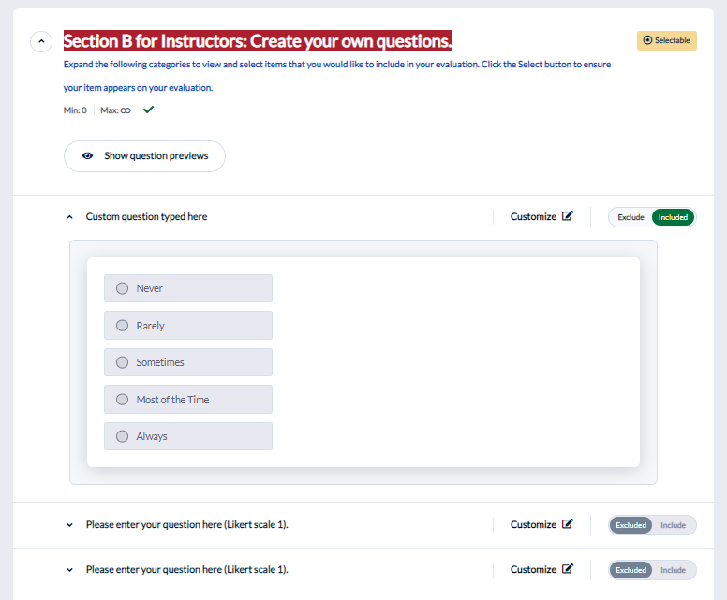

Once you select a question you then click on the Customize icon to type in your own words for it.
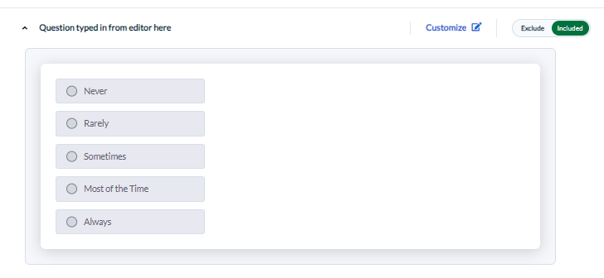

Copying QP from one section to another
Save time by copying your customized questions from one course section to another! You can still change questions as needed after the copy procedure is completed. Starting in fall 2022, you will also be able to copy your questions from a previous semester’s sections as well as the current one.
This option can be activated by clicking on the two page icon in the upper right of your QP area. This is shown on page two of this handout, item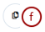 .

You have two copy options:
- Copy selection from - Allows you to copy questions you have already selected in a different course to this evaluation.
- Copy selections to - Allows you to copy questions you have selected in this evaluation to one or several of your other courses.

Copy selection from
- Click Copy Options from the Question Personalization menu.
- Select Copy Selections From . A window will appear named Copy selections from.
- Search for the course name you wish to copy the questions from and select it.
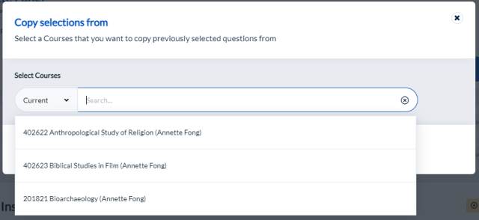
- Select Copy to finalize the process.
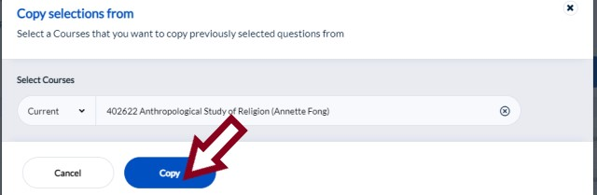

Copy selections to
- Click Copy Options from the Question Personalization menu.
- Select Copy Selections To . A window will appear named Copy selections to.
- Search for the course name you wish to copy the questions to and select it.
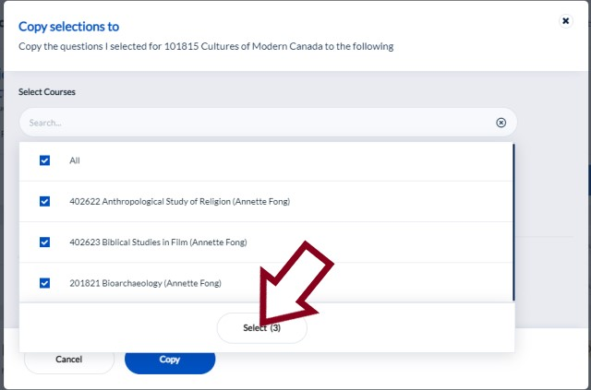
- Choose to only copy the questions, or copy and submit the task immediately.
- Select Copy to finalize the process.
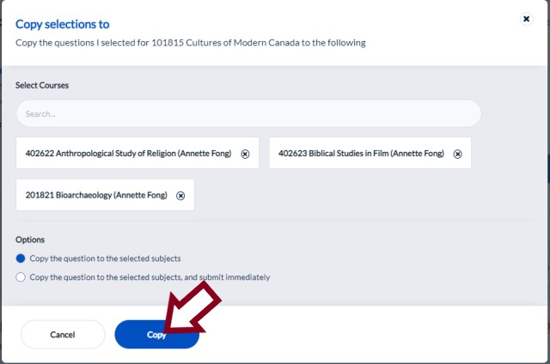
Caution! Choosing to copy and submit can save you the step of manually submitting a task for each course one by one. However, don’t forget to open that section to review or modify the questions. Any changes can be made by “Updating” your evaluation. Updates can happen until the first day students begin filling them out.

Important Information for Team Taught Courses
All added QP questions will be put in the Instructor Section of the evaluation. This means that the personalization an instructor does will not affect any other instructor’s evaluation.
This can be problematic for team taught courses. If you want an added question to show up for each instructor of a team taught section, each instructor will need to be aware of this and add it as part of their individual QP task.
On the other hand, this is useful if different instructors within a team taught course want different questions.
Instructor Section Reports created will include the general course question section and then the individual’s instructor questions. Instructor A will not see answers to Instructor B’s questions even if they are team teaching the same section. Both Instructor A & B will be able to see the common course questions.

Universal Program Questions – Contact CDS
If your program has questions it needs added to all course evaluations please contact CDS. We can work with your program to develop a system so that the required questions will not need to be individually added each semester.
This is for program use only. Depending on the request, and its timing, it will take at least one semester to implement.

Previewing Student View of the Evaluation
Using the preview button (item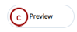 from the page two diagram) you can move through an example evaluation just as your students would. You can use this to see both the original default evaluation and your changed one. However, your changes will not appear in the preview until they have been saved in the QP area.
This preview is opened in a separate browsing window/tab. When you are done looking at it simply close the tab to get back to your QP area.
Caution! Important to remember, this is a totally separate window and you are moving through it as a student but it does NOT affect your evaluation in any way. Therefore when you get to the end of the preview and hit “Submit” it is just the sample. You must still submit your survey using the buttons located in the QP area. Only those will complete your work.

Team Taught Courses have an extra item
When you have a team taught course students have an extra page to work through. This page lists all the instructors in the section. Students can select one or more instructors to evaluate by checking a box next to their name. However, during your evaluation preview only your name will be shown and you must select that box so that when you get to the next preview page you will see the general course questions AND your individual instructor questions. If you forget to click that box you will only see general course questions. You can move back in the example, just like a student, and click by your name to fix that.
No matter how many faculty names the student selects, the student will only fill out one evaluation in total. All custom questions will be separated to the individual faculty section reports – you will only see the questions you created on your report and other faculty will not see your questions.

Submitting Your Evaluation
Faculty can use links in emails/popups which go directly to their Subject Management area. You can also access this area from the list on your Blue home page or the Subject Management link on the top of the home page. More details can be found on this process in the “Accessing your Blue home page” handout.

Submitting
If using the default evaluation set up, or after customizing your evaluation, you must submit your evaluation to stop D2L and email reminders. If you have made any changes you must also submit the QP task for them to take effect.
After opening the Subject Management Area you will need to select the box representing the section you are submitting and from there open the Question Personalization (QP) area. Accessing QP from the Subject Management area is detailed below.

Opening QP
Once in your Subject Management area, select the evaluation block you want to submit and click View Settings.

In the “Choose your questions” section click on the arrow pointing right. This will take you to the Question Personalization area.

At this point select either submit option, shown in the screen shot below, and follow any screen prompts.
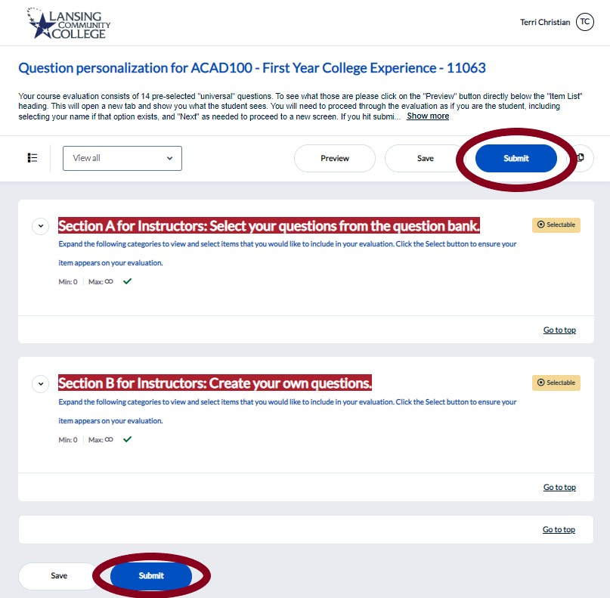

Doing nothing
Once receiving notification that the QP task is available you may receive 2 email reminders and a D2L popup when logging in. Once the student evaluation is open for them to fill out these emails/popups will end and the default evaluation will have been used.
It is acceptable to use the default evaluation. You can ignore email reminders and popups regarding customizing your evaluation and your students will still receive their required evaluations at the end of the semester.

Where to submit questions/comments

Questions regarding information from this Handout
Please direct any questions regarding information from this handout to the Center for Data Science at lcc-cds@star.lcc.edu. CDS will reply to your email as soon as possible.

Offering comments and/or other feedback regarding Blue Student Course Evaluations
This system is ever evolving and your input is valued. Please send any comments or other feedback to the Center for Data Science at lcc-cds@star.lcc.edu. Content/system changes will be forwarded to CASL for their review and discussion. Any proposed content/system changes will be voted on during their meeting and implemented by CDS upon their request.
---
LCC provides equal opportunity for all persons and prohibits discriminatory practices based on race, color, sex, age, religion, national origin, creed, ancestry, height, weight, sexual orientation, gender identity, gender expression, disability, familial status, marital status, military status, veteran's status, or other status as protected by law, or genetic information that is unrelated to the person's ability to perform the duties of a particular job or position or participate in educational programs, courses, services or activities offered by the College.
The following individuals have been designated to handle inquiries regarding the nondiscrimination policies: Equal Opportunity Officer, Washington Court Place, 309 N. Washington Square Lansing, MI 48933, 517-483-1730; Employee Coordinator 504/ADA, Administration Building, 610 N. Capitol Ave. Lansing, MI 48933, 517-483-1875; Student Coordinator 504/ADA, Gannon Building, 411 N. Grand Ave. Lansing, MI 48933, 517-483-1885; Human Resource Manager/Employee Title IX Coordinator, Administration Building, 610 N. Capitol Ave. Lansing, MI 48933, 517-483-1879; Student Title IX Coordinator, Gannon Building, 411 N. Grand Ave. Lansing, MI 48933, 517-483-9632.

