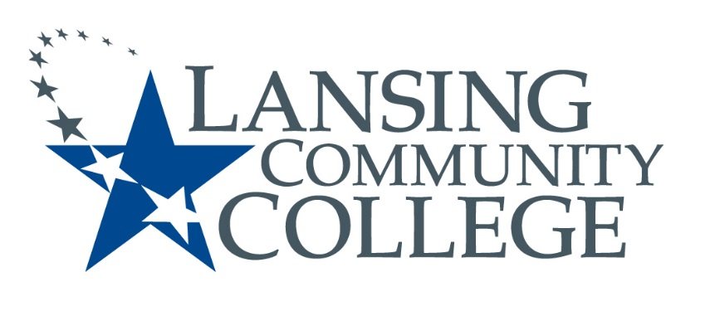
Public Meeting Notice

LANSING COMMUNITY COLLEGE
Human Subjects Institutional Review Board Meeting
Friday, November 8, 2024
9:10 am – 10 am
515 North Washington Square Lansing, MI 48933
Health and Humans Services Building, Room 104

For more information, please go to IRB Consumer information
(https://lcc.edu/consumer-information/institutional-review-board.html) or call
Center for Data Science at 517-483-1123

Hybrid guest participation is available upon request, send email to HS-IRB, lccirb@star.lcc.edu, to request a meeting link
---
Lansing Community College is an equal opportunity educational institution/employer. Lansing Community College programs and activities are open for all persons regardless of race, color, sex, age, religion, national origin, creed, ancestry, height, weight, sexual orientation, gender identity, gender expression, disability, familial status, marital status, military status, veteran’s status, or other status as protected by law, or genetic information.

