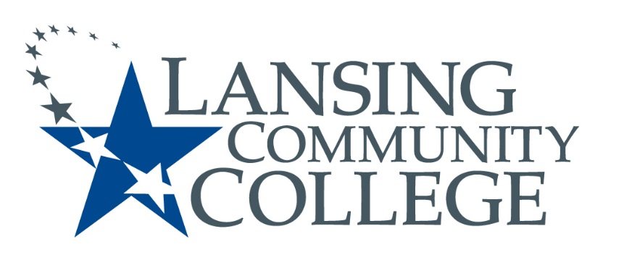
Public Meeting Notice

LANSING COMMUNITY COLLEGE
Human Subjects
Institutional Review Board Meeting
Friday, March 5, 2021
Via WebEx
11am – 12pm

Please contact Terri Christian at christt4@star.lcc.edu to receive a link or call in number to participate.
For more information, please go to IRB Consumer information (https://lcc.edu/consumer-information/institutional-review-board.html) or contact Terri Christian at 517-483-1123

Lansing Community College is an equal opportunity educational institution/employer. Lansing Community College programs and activities are open for all persons regardless of race, color, sex, age, religion, national origin, creed, ancestry, height, weight, sexual orientation, gender identity, gender expression, disability, familial status, marital status, military status, veteran’s status, or other status as protected by law, or genetic information.

