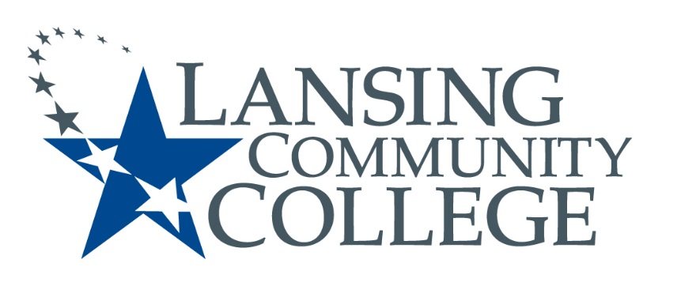

Public Meeting Notice

LANSING COMMUNITY COLLEGE
Institutional Review Board Meeting
Thursday, June 21, 2018
610 N. Capitol Avenue
Lansing, MI 48933
ADM 200
2pm – 3pm

For more information, please go to https://lcc.edu/cds/irb/ or contact Matthew Fall at 517-483-1953

