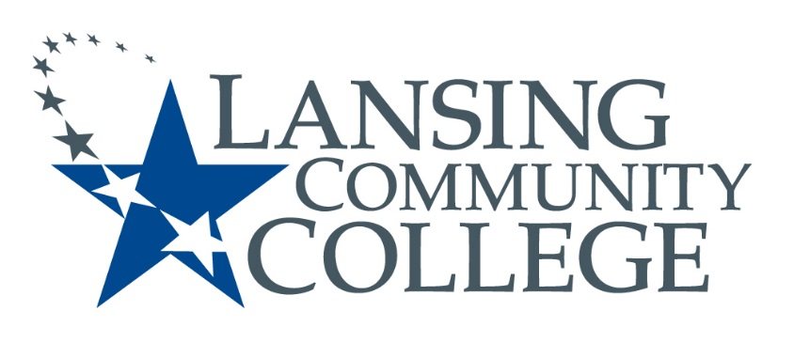

Public Meeting Notice

LANSING COMMUNITY COLLEGE
Institutional Review Board Meeting
Friday, March 6, 2018
610 N. Capitol Avenue
Lansing, MI 48933
ADM 200
9am – 10am

For more information, please go to https://lcc.edu/cds/irb/ or contact Grace Howe at 517-483-1123

