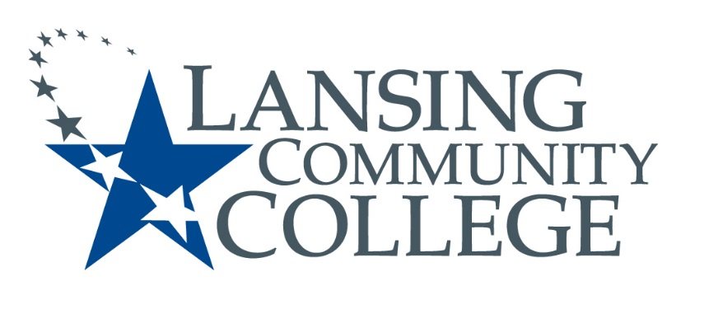

Public Meeting Notice

LANSING COMMUNITY COLLEGE
Institutional Review Board Meeting
Friday, September 7, 2018
610 N. Capitol Avenue
Lansing, MI 48933
ADM 200
11am – 12pm

For more information, please go to https://lcc.edu/consumer-information/institutional-review-board.html or contact Matthew Fall at 517-483-1953

